Project Design Phase
Solution Architecture

Date | 30 September 2026
Team ID
Project Name | AI Study Buddy API
Maximum Marks | 4 Marks

Solution Architecture:
Solution architecture is a complex process – with many sub-processes – that bridges the gap between business problems and technology solutions. Its goals are to:
- Find the best tech solution to solve existing business problems.
- Describe the structure, characteristics, behavior, and other aspects of the software to project stakeholders.
- Define features, development phases, and solution requirements.
- Provide specifications according to which the solution is defined, managed, and delivered.
Solution Architecture Diagram: AI Study Buddy API
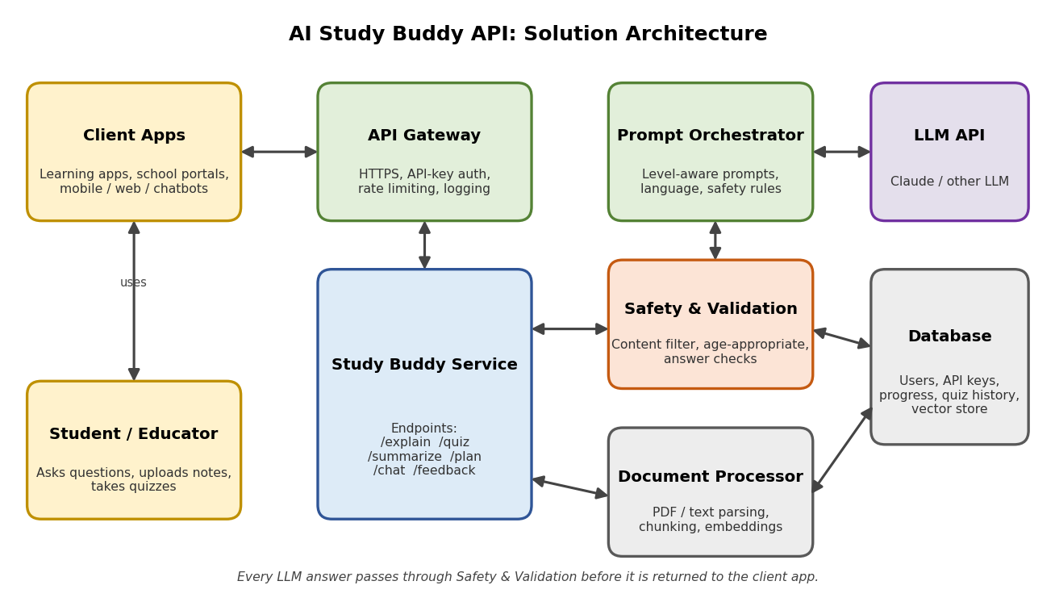
Figure 1: Architecture and data flow of the AI Study Buddy API
Components:
Component | Responsibility
Client App / Frontend | Web, mobile or chatbot interface of the learning app; sends requests with the API key and shows responses.
API Gateway | Single entry point over HTTPS; handles API-key authentication, rate limiting, request validation and logging.
Study Buddy Service | Core backend with the /explain, /quiz, /summarize, /plan, /chat and /feedback endpoints.
Prompt Orchestrator | Builds prompts based on the student's level, subject and language; controls hints vs. full answers.
LLM API | Large language model that generates explanations, questions, summaries and plans. It can be replaced without changing the API.
Safety & Validation | Filters unsafe or age-inappropriate content and checks answer format (for example, valid quiz JSON).
Document Processor | Parses uploaded PDFs and notes, splits them into chunks and creates embeddings for note-based answers.
Database / Vector Store | Stores users, API keys, usage, progress, quiz history and note embeddings.
Data flow:
- The student uses a learning app, which sends a request (for example, POST /quiz) with an API key to the API Gateway.
- The gateway checks the key and rate limit, then forwards the request to the Study Buddy Service.
- If notes were uploaded, the Document Processor retrieves the relevant passages from the vector store.
- The Prompt Orchestrator builds a level- and language-aware prompt and calls the LLM API.
- The Safety & Validation layer checks the LLM output; approved results are returned to the app and progress is saved.
Technology stack (proposed):
- Backend: Python (FastAPI) or Node.js REST service
- AI: Large language model via API
- Storage: PostgreSQL for users and progress, a vector database for note embeddings
- Deployment: Docker containers on a cloud platform, with HTTPS and API-key security
Reference: Template structure adapted from the AWS solution architecture example: https://aws.amazon.com/blogs/industries/voice-applications-in-clinical-research-powered-by-ai-on-aws-part-1-architecture-and-design-considerations/

